

Table of Contents

**1.1 Who Is this application for?** **2**

**1.2 Who should use this guide** **2**

**2.1 Key Features Retail** **3**

**2.2 Key Features for Hobbyist** **3**

**3.1 Launch Screen** **4**

**3.2 Sets and Cards** **5**

**3.3 Add/Remove inventory** **8**

**3.4 Customer Table** **9**

**4.1 Launch Screen** **10**

**4.2 Sets and Cards** **11**

**4.3 Add/Remove inventory** **13**

1 Target Audience

# 1.1 Who Is this application for?

Tracking an ever growing of appreciating Magic the Gathering cards can be a daunting task for both professional and amateur enthusiasts

Retailers of Magic the Gathering struggle to keep track of fluctuating market values of cards, as well as their own inventory. This application provides a simple way for retailers to manage their inventory as well as current market values.

Consumers collect many Magic the Gathering cards high and low value of varying condition. Tracking the market value of different cards at each condition level is exceptionally difficult and time consuming and this application provides a method to do both simultaneously.

# 1.2 Who should use this guide

This guide is intended for new users of the Magic the Gathering Database

* Retail Employees can learn how track the store Magic the Gathering collections and track the purchases made by each customer.
* Hobbyist can learn how to access a database that tracks the current market value of Magic the Gathering cards and the market value of different conditions of each card

2- Key Features

# 2.1 Key Features Retail

The following are key functions available to Retail employees and Retail managers:

* Tracks customer purchase information including cards purchased, average purchase, and loyalty rewards.
* Shows card collection organized by name, condition, color, set, card type, and value.
* Maintaining inventory.
* Add and remove card from inventory.

# 2.2 Key Features for Hobbyist

The following are key functions available to users who are hobbyist:

* Shows card collection organized by name, condition, color, set, card type, and value.
* Maintaining inventory.
* Add and remove card from inventory.

3 Retail Users - A guided Tour

# 3.1 Launch Screen

Upon launching the program, users will first see the landing page. (fig1)with the name of the company and the name of the database. Underneath the title there is a button with the text “**Open**.” In order to progress further in the application the user must click on the “**Open**” button.

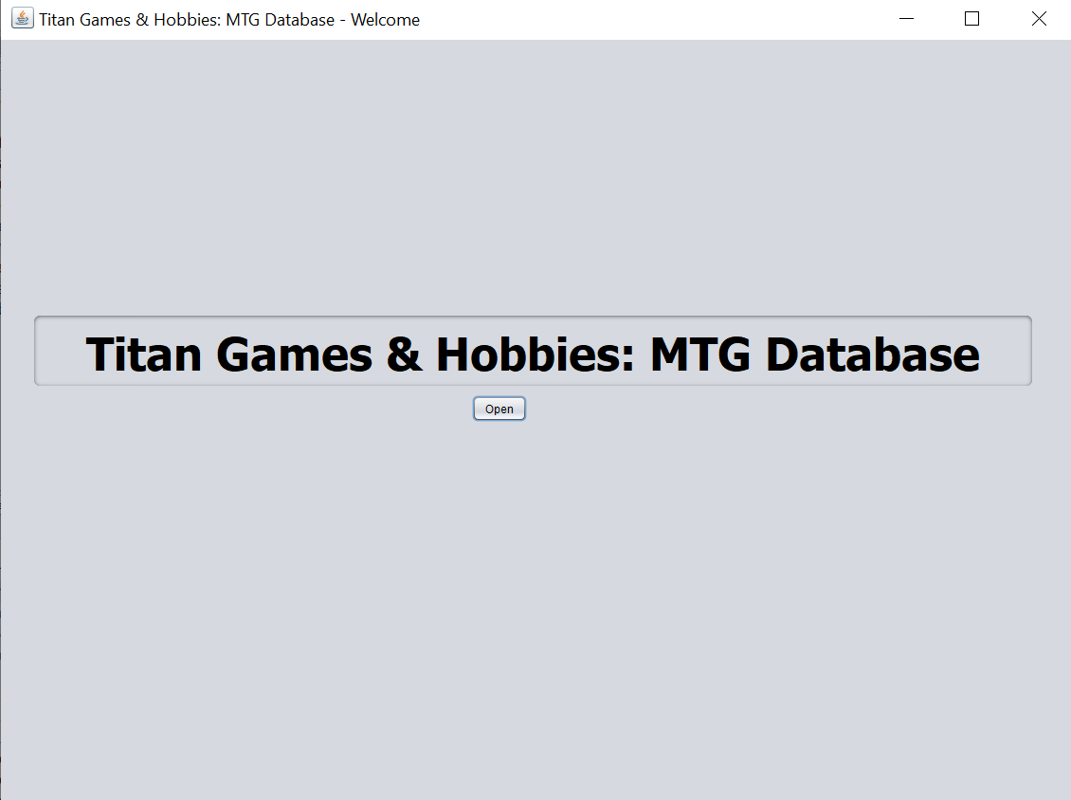

fig1

Upon clicking the “Open” button the users will see application main page (fig2). A welcome message is displayed as well as a list of the functions the application provides. At the top of the window there are four buttons. “**Home**,” “**Cards**,” “**Sets**,” and “**Customer**,” and “**Exit”** These five buttons stay on the application at all times giving the user the ability to jump between the different functions at any moment. The “**Home**” button will always return the user to the screen in fig 2. and “**Exit”** will close the application.

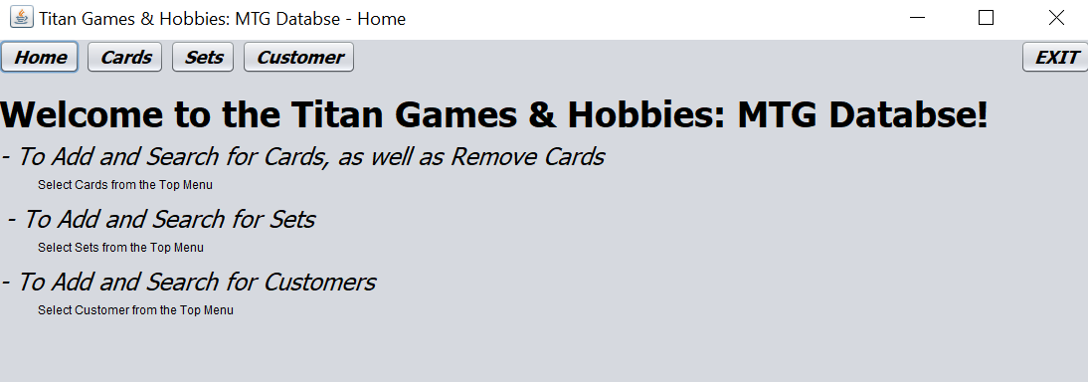Fig 2

# 3.2 Sets and Cards

In order to check inventory the user will click on the “**Cards**” button or “**Sets**” Button. If they click on “**Sets**” (fig 3) will be displayed. From here the user will be able Add a set or search for a set. Under Add Set there are three fields, Name, Release Date, and format. All three fields must be filled before the user clicks on the “**Add Set”** button.

Search set will provide the user with a list of all cards in the inventory matching the search. To do this simple enter the name of the card in the **Name** field under “**Search for set.”**

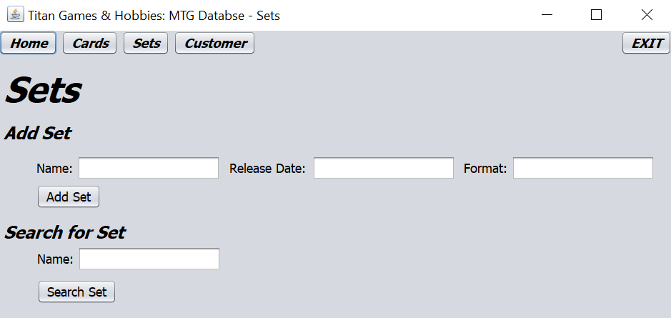

fig 3

Upon clicking the **Cards** button the user will be directed to the Cards screen (fig3). There the user can add, remove, and search for cards as well as input fields for Name, Super Type, Power, Toughness, Loyalty, Sub Type, Set, Color, Mana Cost, CMC, Image Path (for giving the database an image file) A selection menu for condition: M (mint), NM(Near Mint), LP ( Lightly Played), MP (Moderately Played), HP (Heavily Played), and DMG (Damaged). There is also a check box for if the card is Foil or not.

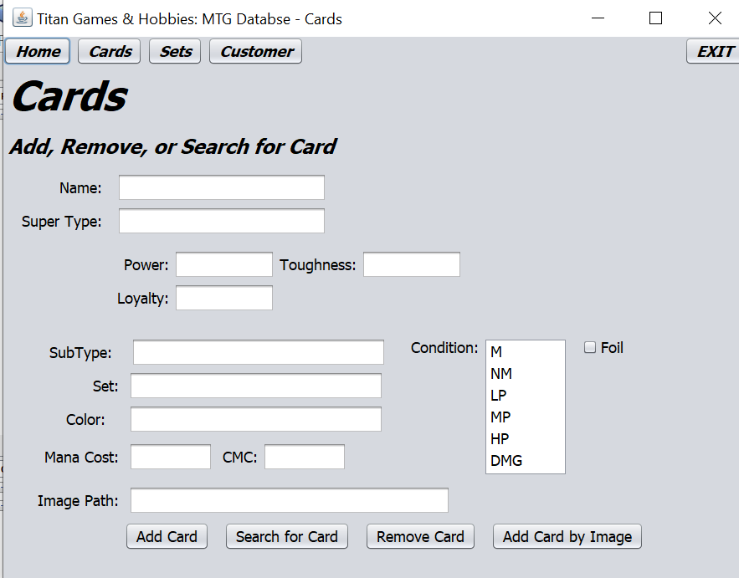

fig 4

# 

# 

# 

# 

# 3.3 Add/Remove inventory

On fig 5 When the user clicks the **add** button the card information is taken directly from the user input fields and entered into the database. For this the user must be precise with the card information because the wrong information can be entered into the database. The **Remove Card** button will remove a single unique card fitting the description given by the user. The **Add Card** by image allows the user to enter the card number and pull the rest of the data from the Wizards of the Coast database.



fig 5

# 

# 

# 3.4 Customer Table

On the customer screen (Fig 6)There are several input fields, under **Add Customer** there are fields for FIrst Name, Last name, Email, Phone Number, and Loyalty Rewards. And under **Search For Customer** There are fields for FIrst Name, Last Name, Email, and Phone Number. To Add a customer fill out the customer’s information and click the **Add Customer** button, the information is entered into the database. To search for a customer fill out the fields under Search For Customer. When complete click the **Search Customer** button.

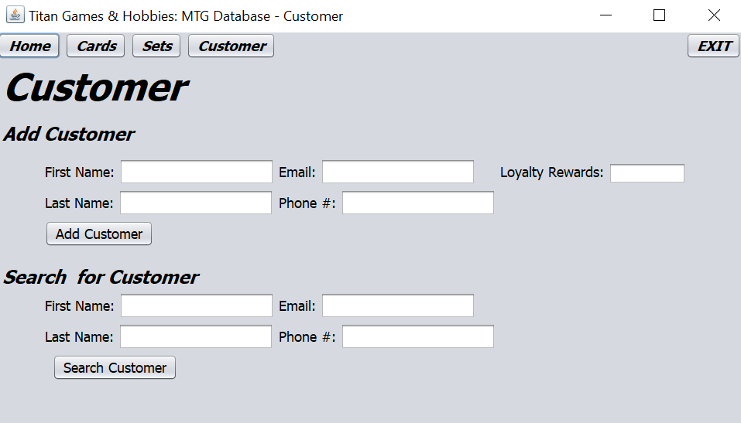

fig 6

4 Hobbyst Users - A guided Tour

# 4.1 Launch Screen

Upon launching the program, users will first see the landing page. (fig7)with the name of the company and the name of the database. Underneath the title there is a button with the text “**Open**.” In order to progress further in the application the user must click on the “**Open**” button.



fig7

Upon clicking the “Open” button the users will see application main page (fig8). A welcome message is displayed as well as a list of the functions the application provides. At the top of the window there are four buttons. “**Home**,” “**Cards**,” “**Sets**,” and “**Customer**,” and “**Exit”** These five buttons stay on the application at all times giving the user the ability to jump between the different functions at any moment. The “**Home**” button will always return the user to the screen in fig 2. and “**Exit”** will close the application.

Fig 8

# 4.2 Sets and Cards

In order to check inventory the user will click on the “**Cards**” button or “**Sets**” Button. If they click on “**Sets**” (fig 9) will be displayed. From here the user will be able Add a set or search for a set. Under Add Set there are three fields, Name, Release Date, and format. All three fields must be filled before the user clicks on the “**Add Set”** button.   
Search set will provide the user with a list of all cards in the inventory matching the search. To do this simple enter the name of the card in the **Name** field under “**Search for set.”**



fig 9

Upon clicking the **Cards** button the user will be directed to the Cards screen (fig10). There the user can add, remove, and search for cards as well as input fields for Name, Super Type, Power, Toughness, Loyalty, Sub Type, Set, Color, Mana Cost, CMC, Image Path (for giving the database an image file) A selection menu for condition: M (mint), NM(Near Mint), LP ( Lightly Played), MP (Moderately Played), HP (Heavily Played), and DMG (Damaged). There is also a check box for if the card is Foil or not.



fig 10

# 

# 4.3 Add/Remove inventory

On fig 11 When the user clicks the **add** button the card information is taken directly from the user input fields and entered into the database. For this the user must be precise with the card information because the wrong information can be entered into the database. The **Remove Card** button will remove a single unique card fitting the description given by the user. The **Add Card** by image allows the user to enter the card number and pull the rest of the data from the Wizards of the Coast database.



fig 11